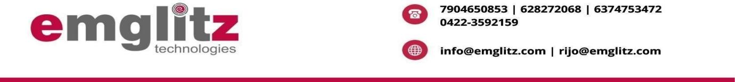

Date: 02/11/2023

TO WHOMSOVER IT MAY CONCERN

This is to certify that the student **Mr. Jishnu B, Mr. Suwinkumar T, Mr. Tanush K, Mr. Udhayarajan M** of Computer Science and Engineering Department of Karpagam College of Engineering, Myleripalayam, Coimbatore has satisfactorily completed their Project Phase I **“Identification of Offensive Language in Social Media Comments and Posts”** during the period **July 2023 to October 2023** under our guidance.

Yours,

K.GOWTHOM SANTHOSH

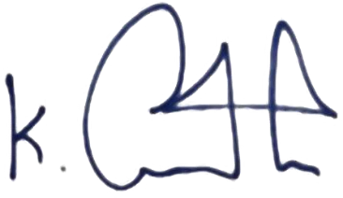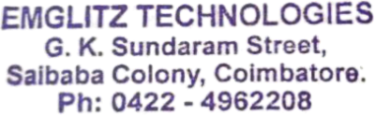

**MANAGING DIRECTOR**

